 | Massachusetts Institute of Technology  Committee on the Use of  Humans as Experimental Subjects | Protocol #  (assigned by  COUHES)

APPLICATION FOR USE of HUMANS AS EXPERIMENTAL SUBJECTS
(Standard FORM)

Please answer every question. Positive answers should include details. N/A must be marked where the question does not pertain to your application. Any incomplete application will be rejected and returned for completion. This application must include the secondary personnel list form otherwise this application will be returned to you.
I. BASIC INFORMATION
1. Title of Study
Accelerating robust, reproducible developmental research via online testing
2. Principal Investigator
Name: Kimberly Scott | Building and Room #:46-4009
Title: Research scientist | Email: kimscott@mit.edu
Department: Brain and Cognitive Sciences | Phone: 617 324 2888
3. Funding. If the research is funded by an outside sponsor, please enclose one copy of the research proposal with your application. A draft of the research proposal is acceptable. Do not leave this section blank. Check all that apply. If your project is not funded, check No Funding.
A. Sponsored Project Funding:
Current Proposal Grant/Proposal #
Sponsor
Title

Current Award Grant/Account #
Sponsor
Title
B. Institutional Funding:
Gift Halis Lookit Platform Fund, #3882820 Departmental Resources
Other (explain)
C. No Funding
This protocol will not be funded
4. STATEMENT OF FINANCIAL INTEREST
Does the investigator, study personnel involved in the study or their family have a financial interest in a company or other organization participating in or providing drugs, devices, biological agents, investigational medical devices, or any other tangible material or financial sponsorship for the research?

Yes No

Does this study contemplate receiving/using any materials/data (data sets, confidential information) or making any purchases from or subawards to a company or other organizations in which you or a family member hold a Financial Interest?

Yes No

If yes was checked for any of the questions above, then attach a Supplement for Disclosure of Financial Interest for each individual with an interest. This supplement, together with detailed guidance on this subject and definitions of the highlighted terms, is available in the COUHES site under Policies & Procedures in the Financial Conflicts of Interest section.

5. Anticipated Dates of Research
Start Date: 4/1/2018 |  | Completion Date: 4/1/2050
6. Collaborating Institutions. If you are collaborating with another institution(s) then you must obtain approval from that institution’s institutional review board, and forward copies of the approval to COUHES.

n/a
7. Location of Research. If at MIT please indicate where on campus. If you plan to use the facilities of the Clinical Research Center you will need to obtain separate approval from the MIT Catalyst Clinical Research Center.

MIT Early Childhood Cognition Lab (ECCL)

II. STUDY INFORMATION
1. Purpose of Study. Please provide a concise statement of the background, nature and reasons for the proposed study. Use non-technical language that can be understood by non-scientist members of COUHES.
The Lookit platform facilitates online research with infants and children, allowing researchers to create and post studies on the Lookit website (https://lookit.mit.edu). Families participate in these studies from a home computer, with webcam video of their responses sent to the lab for later analysis. The purpose of the platform is to lower barriers to conducting and participating in rigorous, reproducible developmental research that advances the understanding of development and its implications for education, parenting, policy, and medicine. Lookit aims to support researchers in working with larger sample sizes (to study small or graded effects with adequate power, or to run necessary manipulation checks); working with more representative and diverse samples; observing more natural behavior in the home environment; recruiting special populations; using longitudinal designs to observe individual differences, changes over time, and effects of interventions; and sharing protocols and materials to enable cumulative and reproducible scientific progress.

Data collected on Lookit will be used to monitor and improve the platform. We may use data to
detect and fix technical problems or identify new features that would be helpful; provide support to study researchers; assess data quality (for instance, how well an observer can tell which direction children are looking); develop tools for data analysis; evaluate the site’s success in reaching a diverse population; and characterize family engagement (for instance, looking at what aspects of a study make parents more interested in coming back later).
This study will also encompass ongoing research from protocol #1204005017, in that participant accounts created, children registered, and demographic data recorded on Lookit under that protocol will persist, and study data collected under that protocol may continue be used for the limited purposes described above. Existing participants will continue to be contacted about new studies only in accordance with their email preferences. Because consent to participate is collected separately for each experimental session, they will see the new consent forms before participating in any research under this protocol, i.e. their consent to participate in ECCL-conducted research under the previous protocol is not being construed as consent to participate in research conducted by other labs.

2. Study Protocol. For biomedical, engineering and related research, please provide an outline of the actual experiments to be performed. Where applicable, provide a detailed description of the experimental devices or procedures to be used, detailed information on the exact dosages of drugs or chemicals to be used, total quantity of blood samples to be used, and descriptions of special diets.
For applications in the social sciences, management and other non-biomedical disciplines please provide a detailed description of your proposed study. Where applicable, include copies of any questionnaires or standardized tests you plan to incorporate into your study. If your study involves interviews please submit an outline indicating the types of questions you will include.
You should provide sufficient information for effective review by non-scientist members of COUHES. Define all abbreviations and use simple words. Unless justification is provided for additional length, this part of the application must not exceed 5 pages.
Attaching sections of a grant application is not an acceptable substitute for a description of your study as requested here.

This protocol is unusual in that, while we will facilitate other researchers’ collection of developmental data, the individual studies on the Lookit platform will generally be conducted by other researchers, and will be reviewed separately by the appropriate institutional review board. Before beginning to use Lookit for recruitment and testing, researchers must sign and return the Lookit Usage Agreement (see attached).

On Lookit, infants and children from birth through seven years of age and their parents/legal guardians may participate in studies. All subjects participate from a familiar environment (usually their own home) over the internet. Audio and video data are recorded via webcam while they complete a study in the web browser, and streamed to a Lookit server for later analysis.

To participate, a parent first creates an account on the Lookit site, adds at least one child to the account, and fills out a demographic survey. Then he or she can select a current study to participate in, based on the child’s age and other eligibility criteria. At the beginning of a study, a consent form is displayed and the parent is asked to read aloud a statement of consent which is recorded via webcam. At the conclusion of the study, the parent is asked to select a privacy level for the videos collected, and has the opportunity to withdraw video from the study.

An individual study protocol is designed by the responsible research group, and will be subject to any applicable institutional review at that institution. In addition, studies are subject to approval by Lookit personnel prior to being posted on the site, both initially and after any substantive changes are made. Approval requires Lookit admin permissions not granted to other researchers using the platform. This review allows Lookit personnel to verify that the study submitted runs smoothly and is clear for parents and children, to advise on design as needed (e.g. suggesting ways to make a study more interactive and engaging to improve data quality), and to verify compliance with the Lookit Usage Agreement which governs acceptable uses of the platform.

A typical infancy study would involve displaying a short video or a sequence of images with accompanying audio to an infant in order to measure looking time or preferential looking. Older children may additionally see more abstract representations of scenarios or data (e.g., storybooks, charts, maps). Participants may be asked to give verbal responses to questions or to look or point at particular objects on the screen. The parent or guardian of an infant or child participant may be instructed to read a script, interact with the child, incorporate materials readily available at home, or draw the child's attention to a particular aspect of the display. Alternately the caregiver may be asked, as in typical lab studies, to try to avoid speaking with the child or paying attention to the display until the experiment is over. Wherever possible, if parents are asked not to view or listen to stimuli during the study, they are offered the opportunity to preview the stimuli without their child beforehand.

Looking time, direction of gaze (e.g. to the left or right of the screen), overt responses (e.g. facial expressions, pointing), and/or verbal responses may be coded from the webcam video recorded. This is noninvasive and requires no additional equipment beyond the webcam. Adult participants, older child participants, and parents of child and infant participants may also be asked to provide written or multiple-choice answers to questions. For instance, a six-year-old might be asked to click on the toy animal he thinks is really inside a box after hearing guesses from several characters. Parent speech and behavior may also be coded when relevant; the parent, parent-child dyad, or interaction may be the subject of study.

Children are always in the presence of a parent during the study; their positioning is generally at the parent’s discretion (e.g. in a high chair, held on the parent’s lap, or sitting independently in front of the parent). No infancy experiment session (for children 0-12 months) will be designed to last longer than 30 minutes, and no experiment session will be designed to last longer than 90 minutes, although typical studies are much shorter.

The participant (and/or the participant’s parent or guardian, as applicable) has the option to stop the experiment at any point by pressing a key or closing the browser window. They may also choose for any reason upon completing or ending the session to withdraw their video data from the study; in this case no video beyond the consent recording will be viewed.

Because some studies are training studies, or focus on individual differences or change over time, we may run multiple sessions with the children. Families may participate in as many or as few sessions as they choose. Families may be invited by email to participate in follow-up sessions if they have set their communication preferences accordingly.

3. Drugs and Devices. If the study involves the administration of an investigational drug that is not approved by the Food and Drug Administration (FDA) for the use outlined in the protocol, then the principal investigator (or sponsor) must obtain an Investigational New Drug (IND) number from the FDA. If the study involves the use of an approved drug in an unapproved way the investigator (or sponsor) must submit an application for an IND number. Please attach a copy of the IND approval (new drug), or application (new use.).
If the study involves the use of an investigational medical device and COUHES determines the device poses significant risk to human subjects, the investigator (or sponsor) must obtain an Investigational Device Exemption (IDE) number from the FDA.
Will drugs or biological agents requiring an IND be used? YES NO
If yes, please provide details:
Will an investigational medical device be used? YES NO
If yes, please provide details:
4. Radiation If the study uses radiation or radioactive materials it may also have to be approved by the Committee on Radiation Exposure to Human Subjects (COREHS). COUHES will determine if you need COREHS approval.
Will radiation or radioactive materials be used? YES NO
If yes, please provide details:
Will any type of lasers be used YES NO
If yes, please provide details:
5. Diets
Will special diets be used? YES NO
If yes, please provide details

III. PERSONNEL
Fill out the personnel list attached to this form. If the personnel list is not included, the application will be returned to you.

IV. HUMAN SUBJECTS
1. Subjects (that will be consented for this study)

- Maximum number of subjects: 30000  Adults: Minors: | Age(s): Neonates – seven years and their parents or legal guardians
C. Inclusion/exclusion criteria
i. What are the criteria for inclusion or exclusion? All parents will be able to provide informed consent (either by reading aloud in English or in ASL). All families will have a working computer, webcam, and internet connection in order to proceed through a study. Individual studies may have additional criteria, including criteria based on children’s ages, gestational ages at birth, gender, or behavior during an initial section of a study.

ii. Are any inclusion or exclusion criteria based on age, gender, or race/ethnic origin? If so, please explain and justify. This is a platform for developmental research, so age is generally a factor in participant inclusion. For our own research questions, no inclusion criteria are based on gender or race/ethnic origin.

Individual studies may use age and/or gestational age at birth (e.g. born at 32 weeks vs. 40 weeks) as an inclusion criterion and/or to generate adjusted ages for premature infants. Individual studies may test hypotheses about other characteristics including gender, race, ethnic origin, linguistic background, family structure, vision or hearing impairments, developmental or genetic disorders, or motor development, and therefore recruit subjects and/or exclude data on these bases. Families and children are never prevented from taking part in studies, but their data may not be used in primary analyses if they do not meet the inclusion criteria.

iii. Please explain the inclusion of any vulnerable population (e.g. children, cognitively impaired persons, non-English speakers, MIT students), and why that population is being studied.

As developmental researchers, our goal is to characterize the early stages of learning and reasoning, so children are the focus of our research.

2. Subject recruitment Identification and recruitment of subjects must be ethically and legally acceptable and free of coercion. Describe below what methods will be used to identify and recruit subjects. Attach any and all recruitment documents associated with the protocol (i.e. flyers, e-mails, advertisements, etc.)
Participation will be possible via the Lookit website (https://lookit.mit.edu). A brief description of the platform, including a link, may be posted for interested parents on relevant online websites or fora including on social media (e.g. BabyCenter, MIT's FamilyNet, Twitter, parenting Facebook groups or subreddits) or sent to family-related email lists, subject to their own regulations. Information about the site may be posted on the ECCL website, and distributed via flyers or contact cards at institutions families visit (e.g. the Boston Children’s Museum, pediatrician offices, daycares, libraries) subject to those institutions’ guidelines. On social media, other people who choose to share the content may do so. Upon completing a study, we may display a link to share information about the study on social media. We may suggest that parents share information about Lookit or about studies they have enjoyed with friends.

Online posts and discussions about Lookit may mention new or ongoing individual studies conducted on the platform and/or research progress enabled by Lookit. To advertise information more likely to be of interest, studies appropriate to a specific audience may be highlighted: for example, mentioning in a posting to an infant parenting discussion group that there’s a new study from Yale about infants’ perception of music, and mentioning in a posting to a preschool community group that there are 10 studies available for children ages 3-5 about topics ranging from cooperation to healthy eating to counting.

As information about specific studies may be more likely to interest parents new to Lookit than information about the platform as a whole, Lookit may also help to publicize individual studies in appropriate communities by providing a brief description of a study and a link to learn more on Lookit. For instance, we might post in a Facebook group for parents of 7-month-olds that there’s a new study for 7-month-olds about shape perception that they can try on Lookit. However, the family’s decision about whether to participate is always made privately, online, while viewing a written description of the aim of the study, time involved, and procedures. In contrast to recruitment for an in-lab study, there is no social pressure or “commitment to participate” earlier in the process, for instance on the phone with study staff to schedule a visit.

Researchers using the platform will recruit participants for their own studies, subject to any restrictions imposed by their own IRB. They may also participate in recruiting for the Lookit platform more generally, e.g. by posting flyers locally, mentioning it to in-lab participants, or posting on social media.

Current Lookit users (families with an account) will receive automated emails announcing new studies that their children are eligible for (either when a new study is posted, or when their child enters the age range). These emails will give a brief description of the study, provided by the responsible researcher, and a link to learn more. Users only receive these emails if they have chosen to receive announcements of new studies, and can change their email preferences at any time. All automated emails contain a link to change email preferences/unsubscribe.

V. INVESTIGATOR’S ASSURANCE
3. Informed consent. Documented informed consent must be obtained from all participants in studies that involve human subjects. You must use the templates available on the COUHES website to prepare these forms. Draft informed consent forms must be returned with this application. Under certain very limited circumstances, COUHES may waive the requirement for informed consent. If you are requesting a waiver or alteration of consent, please attach the Waiver or Alteration of Informed Consent Request form.
[Attach informed consent form(s) with this application.]
See attached consent form and application for waiver of documentation of signatures.
4. Subject compensation. Payment must be reasonable in relation to the time and trouble associated with participating in the study. It cannot constitute an undue inducement to participate.
Describe all plans to pay subjects in cash or other form of payment (i.e. gift certificate):
Researchers using the Lookit platform may choose whether to pay participants, and the form of payment, subject to any applicable IRB review at their own institutions. Information about compensation will be posted along with study descriptions and is subject to review and approval by Lookit personnel along with the rest of the study protocol. Researchers may independently choose to email gift certificates or mail physical items (e.g., a book or small toy) to participants as compensation for participating, using account data on file. Participants are never required to provide a mailing address to participate, and the mailing address is used solely for sending such awards; it may not be used for other communication.

Researchers also have the option to award participants points that are accumulated by users across studies on Lookit. These points are always redeemable on the Lookit site for gift certificates at a posted rate, and may also be redeemed for other items (e.g., books, toys, baby gear), via a “store” administered by the Lookit project. Researchers are responsible for verifying participation and awarding points appropriately for sessions where a child participated. Points may be limited to one session per child within a given timeframe and may depend on the family successfully submitting at least a valid consent video and on there being a child of approximately the expected age visible. Awarding of points may depend on the parent’s behavior but may not depend on the child’s behavior or performance, even if the child’s behavior makes the data unusable (e.g., points may not depend on “correct” answers given by a child or whether an infant fusses during a study). For longitudinal studies, points may be allocated unevenly across sessions to reflect the greater value of data collected later in the study and the and greater commitment required by parents to return for a follow-up.

Lookit may set acceptable ranges for the monetary value of study compensation, both points and other independent compensation, as necessary to avoid coercive payment or large disparities between studies.

Lookit, rather than individual researchers, may also choose to offer points for study participation, for instance to balance participation across studies. To encourage family engagement, Lookit may also offer points for actions other than specific study participation, for instance for completing a child’s first or tenth study, completing a study with a second child, completing a reading challenge by reading to the child every day for a week, referring a friend to Lookit, or posting about their study participation on social media).

Will subjects be reimbursed for travel and expenses?
Generally, subjects will not be reimbursed for travel and expenses, as we do not anticipate any expenses or travel associated with participation. However, we may in some cases provide webcams to families who would otherwise be unable to participate, as part of efforts to recruit a more representative population.

5. Potential risks. A risk is a potential harm that a reasonable person would consider important in deciding whether to participate in research. Risks can be categorized as physical, psychological, sociological, economic and legal, and include pain, stress, invasion of privacy, embarrassment or exposure of sensitive or confidential data. All potential risks and discomforts must be minimized to the greatest extent possible by using e.g., appropriate monitoring, safety devices and withdrawal of a subject if there is evidence of a specific adverse event.
What are the risks / discomforts associated with each intervention or procedure in the study?
There are no known risks for these studies. We do not anticipate that participants will experience any discomfort from these studies; however, babies may become fussy and children and adults may become bored.

Parents may be uncomfortable sharing video of their child’s participation, or may have concerns about how the video will be used. We have several measures in place to minimize risk and make sure we only use videos in ways parents are comfortable with (see below).

As with any in-lab studies, when data is published from multiple Lookit studies that a family has participated in, it may be possible for a reader to connect an account or child across multiple studies. (For instance, if the parent opted to allow scientific or public sharing of both videos, he or she may be recognizable as the same person in each; or a particular set of responses to a language or motor development survey may be unique within the Lookit participant pool.)

Contacting parents by email has the potential to be a nuisance if parents cannot opt out easily. For this reason we allow parents to set their own communication preferences and provide a link to change these preferences as a footer in all automatic emails.

What procedures will be in place to prevent / minimize potential risks or discomfort?
The parent or guardian will be able to remain in the room with the child throughout the experiment. Caregivers will be instructed that they can pause or stop the experiment at any point.

In order to ensure that parents understand and accept the potential uses of their video or audio recordings, they are able to select from three privacy levels after each study:

The following text describing privacy levels is shown at the end of each study:

Data sharing

Would you like to share your video and other data from this session with authorized users of the secure data library Databrary?
[] yes [] no

Only authorized researchers will have access to information in the library. Researchers who are granted access must agree to maintain confidentiality and not use information for commercial purposes. Data sharing will lead to faster progress in research on human development and behavior. If you have any questions about the data-sharing library, please visit Databrary < https://nyu.databrary.org/ > or email ethics@databrary.org.

Use of video clips and images

() Private: Video may only be viewed by authorized scientists. [ If the previous question has been answered, a parenthetical note describing who is authorized will be added: “(This means the MIT researchers who run Lookit and the [Institution] researchers working on [Study name])” if no and “(This means the MIT researchers who run Lookit, the [Institution] researchers working on [Study name]), and authorized Databrary users)” if yes.]

() Scientific and educational: Video may be shared for scientific or educational purposes by any of the authorized scientists described above. For example, we might show a video clip in a talk at a scientific conference or an undergraduate class about cognitive development, or include an image or video in a scientific paper. In some circumstances, video or images may be available online, for instance as supplemental material in a scientific paper.

() Publicity: Please select this option if you'd be excited about seeing your child featured on the Lookit website or in a news article about this study! Your video may be shared for publicity as well as scientific and educational purposes; it will never be used for commercial purposes. Video clips shared may be available online to the general public.

Withdrawal of video data
Even if something went wrong, every video is useful to us! However, if you need your video deleted (your spouse was discussing state secrets in the background, etc.), check here to completely withdraw your video data from this session from the study: []
Only your consent video will be retained and it may only be viewed by the MIT researchers who run Lookit and the [Institution] researchers working on [Study name]. Other video will be deleted without viewing.

Private use of video and not sharing with Databrary will be assumed in the event that technical difficulties prevent a parent from selecting from these three options at the conclusion of the study.

To avoid unexpected use of participant identity across studies by Lookit researchers, researchers agree not to publish the unique identifiers used for Lookit accounts or child profiles, and not to use outside information about a participant without specific IRB approval (see 8., “Will data be associated with personal identifiers or will it be coded?”).

In order to ensure that parents do not receive unwanted emails from the Lookit project, they set their own communication preferences under a “Communication” section of the “My account” page. Parents can select whether they would like to receive an email when a new study is available for their child(ren), whether they would like to be reminded when it’s time for another session of a longitudinal study, and whether they would like to hear when results of studies they participated in are published. Parents can also select whether they can be contacted personally if we have any questions about their or their child’s responses. Researchers do not receive direct access to user email addresses; they instead send email through an experimenter interface on the Lookit site by first selecting the type of email to send, then the recipient(s). They are only able to send email to users who have chosen to receive this type of email and who have a child who has participated in at least one of their studies.

6. Potential benefits
What potential benefits may subjects receive from participating in the study?
We do not expect individual children to receive any direct benefit from their involvement, although children usually enjoy participating in these studies. Parents usually enjoy learning more about cognitive development. Parents may be given individualized information about their child’s responses when practical, for instance to show the percentage of time that their infant looked at an unexpected vs. expected outcome in each of several types of events. This is analogous to the certificates often given as keepsakes of participation in lab studies.

What potential benefits can society expect from the study?
The studies on Lookit should advance our understanding of child development, parenting, and education. They may also help to educate parents about current progress in developmental research and about the scientific process.
The creation of this online platform will lower barriers to conducting and participating in rigorous, reproducible research about child development. We expect this to enable a more diverse population both to conduct research and to be represented by its findings. The online environment will also allow researchers to run necessary manipulation checks and work with larger samples to draw more robust and reproducible conclusions. It will also make longitudinal studies and work with special populations much more practical, accelerating research on important questions currently limited by logistical constraints.

7. Data collection, storage, and confidentiality
How will data be collected?
Several forms of data are collected:
- Account data: To create an account, a parent provides an email address and chooses a password. The account is randomly assigned a unique ID string. Account data consists of this unique ID string, an email address, a nickname optionally provided by the parent, a mailing address optionally provided by the parent, a set of email preferences (whether email of various types may be sent to the address on file), and the date/time at which the account was created.
- Child data: At any point after registration, parents can register their children as participants by filling out a brief survey which includes the child’s nickname, date of birth, gestational age at birth, gender, and an opportunity to provide any additional comments likely to be relevant (e.g., hearing or vision impairment). Additional surveys may be made available that provide background information commonly used by researchers, to decrease the burden of participating in multiple studies that require similar information (e.g., motor milestones, vocabulary inventories). Each child is randomly assigned a unique ID string. Child data consists of this information provided about the child, including any such survey data, the unique child ID string, and the ID of the associated account.
- Demographic data: Before participating in their first study, parents are asked to fill out a demographic survey. All questions are optional and this survey may be updated at any point. Each time the survey is updated, a record of its current state is stored; demographic data represents a particular “snapshot” of the survey and consists of the ID of the associated account, a timestamp, and responses to questions about the home environment and family background, including: responding parent’s gender and age, family race(s)/ethnicities, number of parents/guardians, number of children in the home, parents’ education levels, household income, location (country, state, and “urban/suburban/rural”), number of children’s books.
- Study session data: To participate in a particular study, the parent selects a child registered under their account and then completes an activity in the web browser with that child. Session data consists of a timestamp, the associated child ID, any counterbalancing information associated with this session (children may be randomly assigned to different experimental conditions or to see different orders of questions, for instance), and data recorded during each page or “frame” of the study (instructions pages, experimental trials, debriefing page, video privacy level selection page, etc.). Frames record information such as event timing (e.g., when a video started playing, when the user entered/left fullscreen mode), user actions (e.g., which of two animals a user clicked on), and user-entered data (e.g., a form filled out by a parent to describe the child’s sleep habits). If video recording happens during a frame, the filename of the video is included in the frame data.
- Study video: Video recordings (including audio) are collected via participants’ webcams during studies. Video data will be streamed to the Lookit server during the experiment but will not be viewed until a researcher has confirmed consent to participate. Video filenames include the unique ID of the study, the name of the study frame during which the video was collected, the unique child ID, a timestamp, and a random suffix.

Researchers may study relationships between the same child’s behavior in the same study (some studies may comprise multiple sessions, for instance to look at individual differences, test-retest reliability, or the effects of an intervention); between the same child’s behavior in different studies run by the same research group; and between siblings’ behavior on the same study or different studies run by the same research group, all subject to review of any appropriate IRB.

To detect and fix errors encountered by users of the Lookit website, for instance Javascript errors during video recording, error logging will be enabled using Sentry (https://sentry.io/welcome/). Error reports may include IP addresses, usernames, and session IDs. Error reports are securely stored separately from session data and IP addresses are never used for research purposes or to identify participants. Error reports are used only to diagnose and fix problems with the website, not for research purposes, and may be viewed regardless of whether valid verbal consent is obtained for a particular session. Lookit users may also manually submit or email bug reports which may be used to diagnose problems with the website (e.g., incompatibility of the Flash webcam recording widget with a particular web browser). Bug reports about a particular study that are sent to or recorded by the Lookit team may be made available to the individual researchers responsible for the study.

Before viewing video collected during a study session, researchers agree to check for an associated consent recording that demonstrates informed consent. If the parent’s verbal statement of consent is audible, appropriate study measures may then be coded by the researcher. If a technical issue (e.g. lack of audio recording) prevented collection of informed consent, and the parent has set communication preferences to allow researchers to email with questions about their participation, consent may instead be confirmed by contacting the email address on file for the account and receiving back a reply that contains the statement “Yes, I am this child's parent or legal guardian and we both agreed to participate in this study.” Unless consent is confirmed, no other video associated with this study session will be viewed, and no other data from the session will be used in study-specific analysis, although the number of such records and aggregate data about the associated accounts (e.g., how many unique children, how many were in the age range) may be reported. The Lookit Usage Agreement enforces these practices as they apply to other researchers using the platform.

Is there audio or videotaping? YES NO Explain the procedures you plan to follow.
Audio and videotaping of the experiments will be performed via the participants' webcams and streamed to a server maintained by Lookit. Parents have the right to withdraw their video at the conclusion of the study.

Will data be associated with personal identifiers or will it be coded?
Personal identifiers Coded Explain the procedures you plan to follow.
All records, including account and child data, are identified primarily by randomly assigned unique alphanumeric strings. These are used as database keys when retrieving records. While child and demographic data includes the account ID, and session data includes the child ID, the reverse does not hold true: child and demographic ID strings are not included in account data, and session IDs are not included in child data. Therefore, for instance, a researcher who has access to data for a particular account does not automatically have access even to the IDs of all children associated with that account.

Account data encompasses personal information including a nickname (some parents may choose to enter their full name), email address, and optionally a mailing address. While personnel working on the Lookit project may have access to email addresses, email addresses are not revealed directly to other researchers unless participants initiate contact with the researcher or respond to email sent via the Lookit site. Child data encompasses personal information including a nickname (some parents may choose to enter the child’s name), date of birth, gender, and gestational age at birth.

The following restrictions on the use and publication of data apply both to the present study and to other research conducted on Lookit. Other researchers using Lookit are bound by these restrictions via the Lookit Usage Agreement.

Researchers using Lookit:
- May not publish, or conduct research on, child or account names, email addresses, or mailing addresses. Child names must be censored from written comments from parents if published. Parent and child nicknames are used only for communication with the family.
- May not publish child birthdates or information that would allow calculation of child birthdates (i.e., exact age plus date of participation).
- May not publish any of the unique IDs used on Lookit for account, child, or demographic data, as these are shared across the site and would potentially allow a reader to connect children across multiple published studies.
- May not publish demographic data from individuals in a way that would allow a reader to link demographic data to session videos.
- May not use video or other data in order to link outside information available about a specific participant to the child or session, unless they have specific IRB approval to do so. Any planned integration of outside data must be reported to Lookit for review at the time the study is submitted.

Researchers may share video data only in accordance with the parent’s privacy selections at the conclusion of the study. Researchers may share video and other data on Databrary in accordance with parent privacy selections.

Where will the data be stored and how will it be secured?
Data will be both stored by the Lookit project and provided to the individual researchers using the platform. A researcher with access to a particular study will have access to:
- Video and other session data from that study
- Child data from children who participate in the study
- Account data from accounts associated with children who participate in the study
- Demographic data from accounts associated with children who participate in the study

Researchers are not granted access to account email addresses or to child data for siblings of children who participated in a study (unless those siblings also participated).

A researcher accesses the Lookit experimenter interface by authenticating using their Open Science Framework (OSF) account, and authentication is based on OSF access tokens. If granted access to the platform by a Lookit admin, the researcher is then able to create new studies or to be invited to collaborate on an existing study by another researcher who controls that study.

Researchers can download child, account, and demographic data via the Lookit experimenter interface or programmatically via the Lookit API. To use the API, the researcher is provided a key that allows authentication to their account on Lookit. Researchers can download individual study videos via the experimenter interface, or they can download all consent videos or all videos for the study. When a collection of video is requested for download, the video is collected into a .zip archive on Google Cloud storage, and once ready, a unique download link is emailed to the researcher. This long unique link essentially acts as a password to access the archive. The link expires after 30 minutes, so that any later security breach does not compromise the video archive.

Account, child, and demographic databases are stored on the Open Science Framework and are accessible via password-protected OSF accounts with Lookit admin access. Video data is initially streamed to a Wowza Streaming Media Server running on an Amazon EC2 instance, then transferred to an Amazon S3 bucket. The EC2 instance and S3 bucket are accessible via a private key generated when logged in to a password-protected Lookit Amazon Web Services account. Study protocols and video archives are deployed to Google Cloud storage managed by the Center for Open Science. All data may be periodically downloaded to a password-protected computer at ECCL. Study personnel named in this protocol may also temporarily download video and other data onto password-protected devices in order to enable local processing. Additional storage of study data by researchers is subject to any applicable IRB review.

If consent for a session cannot be confirmed, if video is withdrawn at the conclusion of a session, or if a child participant is at least eight years of age, researchers agree to delete without viewing any other associated session video they have downloaded. However, as this determination occurs after the collection of the video data, and based on judgements from the individual researchers, such video data may not be deleted from Lookit storage. Lookit staff, however, will not view video data without themselves confirming consent either. We may check whether video collection is working properly without confirming consent, however, as long as this does not involve viewing the video: for instance using ffmpeg to determine the audio and video codecs and bitrate of video collected.

Automated emails on the Lookit system are mediated via SendGrid, a cloud-based SMTP provider. Lookit user email addresses are used by SendGrid solely on Lookit’s behalf to send email, in accordance with SendGrid’s Services Privacy Policy.

Researchers may share video and other session data on Databrary for sessions where parents opt to allow this usage, subject to approval of the appropriate IRB. Databrary is a secure library developed to allow sharing and reuse of video data from developmental research. From the Databrary mission statement:

“Most developmental scientists rely on video recordings to capture the complexity and richness of behavior. However, researchers rarely share video data, and this has impeded scientific progress. Enabling reuse of video data is essential to increasing openness, maximizing the efficiency of limited resources, and accelerating the pace of discovery in the developmental and learning sciences.”

In order to gain access to the data in the Databrary archive, investigators must be eligible to conduct independent research at their own institution, have human subjects certification, and agree to treat Databrary data with the same high standard of care that they treat data collected in their own lab. Please see the Databrary Access Agreement at https://databrary.org/access/policies/agreement.html for details.

What will happen to the data when the study is completed?
Data will be kept indefinitely on the Open Science Framework, an S3 bucket, and/or on a disk in the lab and, for sessions where parents opted to share their data, on the secure Internet library Databrary. Data may also be stored indefinitely by the researchers responsible for a particular study.

Can data acquired in the study affect a subject’s relationship with other individuals (e.g. employee-supervisor, patient — physician, student-teacher, family relationships)?
There is no foreseeable risk that data collected in this study will affect participants' family, school, or other relationships.
8. Deception Investigators must not exclude information from a subject that a reasonable person would want to know in deciding whether to participate in a study.
Will information about the research purpose and design be withheld from subjects?
YES NO

If YES, explain and justify.
No information is withheld with regards to registration on Lookit or other data provided outside of individual studies. Individual studies that involve deception must notify Lookit and have appropriate institutional approval.
9. Adverse effects. Serious or unexpected adverse reactions or injuries, and/or unanticipated problems involving risks to subjects or others must be reported to COUHES within 48 hours. Other adverse events should be reported within 10 working days.
What follow-up efforts will be made to detect any harm to subjects, and how will COUHES be kept informed?
COUHES will be informed of any known security breach that compromises the privacy of data stored by Lookit, including user, child, demographic, and session data.

10. Health Insurance Portability and Accountability Act (“HIPAA”). If your study (i) involves individually identifiable health information and (ii) is sponsored by MIT Medical, an MIT Health Plan or another healthcare provider, then you must complete the questions below because HIPAA likely applies to your study. For more information regarding the applicability of HIPAA to human subjects research, please click here.
Do you plan to obtain, use or disclose identifiable health information in connection with your research study?
YES NO
If YES, then all participants must complete an Authorization for Release of Protected Health Information Form. Please attach a copy of this draft form. You must use the template available on the COUHES website.

Alternatively, COUHES may grant a Waiver of Authorization in certain very limited circumstances when use of individually identifiable health information would pose only minimal risk to study participants (among other requirements). For additional information regarding whether your study might qualify for a waiver, please click here.
Are you requesting a Waiver of Authorization?
YES NO
If YES, explain your rationale for concluding that: (i) use of participant health information poses no more than minimal risk; (ii) the research could not be conducted without the waiver and (iii) the research could not be conducted without the information. In addition, please explain your plan for (i) ensuring the participant health information is not improperly used or disclosed either within MIT or to any outside third parties and (ii) destroying identifiers at the earliest possible opportunity.
Will the health information you will receive for use in this study be de-identified?
YES NO
If YES, you do not need to obtain a signed Authorization for Release of Protected Health Information Form from study participants. Note, however, that if you receive identifiable participant health information that you plan to convert into de-identified information for use by other researchers, then you must obtain a signed Authorization for Release of Protected Health Information Form from each participant before receiving their identifiable health information for use in your study.
Will you be using or disclosing a limited data set?
YES NO
If YES, and you will only receive participant health information in limited data set form, then you do not need to obtain a signed Authorization for Release of Protected Health Information Form from study participants. You must complete a formal data use agreement with the party from whom you will receive the limited data set information in order for your application to be approved.

If YES, and you will receive identifiable participant health information that you plan to convert into limited data set form for use by other researchers, then you must obtain a signed Authorization for Release of Protected Health Information Form from each participant before receiving their identifiable health information for use in your study. You must complete a formal data use agreement in order for your application to be approved.
I certify the information provided in this application is complete and correct.
I understand that I have ultimate responsibility for the conduct of the study, the ethical performance of the project, the protection of the rights and welfare of human subjects, and strict adherence to any stipulations imposed by COUHES
I agree to comply with all MIT policies, as well all federal, state and local laws on the protection of human subjects in research, including:
- ensuring all study personnel satisfactorily complete human subjects training;
- performing the study according to the approved protocol;
- implementing no changes in the approved study without COUHES approval;
- obtaining informed consent from subjects using only the currently approved consent form;
- protecting identifiable health information, to the extent required by law, in accordance with HIPAA requirements; and
- promptly reporting significant or untoward adverse effects.

Signature of Principal Investigator Date
Print Full Name and Title

Signature of Department Head Date
Print Full Name and Title
By signing this form you confirm a scientific review of the proposed research has been conducted, and that the proposed research is of scientific and scholarly validity.

The electronic file should be sent as an attachment to an e-mail: couhes@mit.edu. In addition, two single sided hard copies (one with original signatures) should be sent to the COUHES office: Building E25-Room 143B.

 | Massachusetts Institute of Technology  Committee on the Use of  Humans as Experimental Subjects | Protocol #  (assigned by  COUHES)

PERSONNEL LIST

This form must be attached to both standard and exempt form applications. Any application submitted without a completed personnel list will be returned to you.
Personnel is defined as anyone who plays a role in research involving human subjects, including direct contact, indirect involvement, analysis of data, blood or tissue samples. This extends to principal investigators, associate investigators, student investigators, study coordinators, visiting scientists, consultants, laboratory technicians and assistants.
All study personnel must be listed below. This listing must include contact information, a brief statement of qualifications and their study role.

Important note: all study personnel are required to complete Human Subject Training before work begins on the project. Proof of training must be attached for non-affiliates. (Documentation from collaborating institutions may be submitted in lieu of training certificates.)

A. MIT AFFILIATES
Personnel name, and e-mail address | Qualifications: Describe briefly | Study role(s): | Check if obtaining consent
Contact*  Name: Kimberly Scott  Email: kimscott@mit.edu | Research scientist, PhD | Platform development, management, support of researchers, data analysis
Name: Kary Richardson  Email: karyrich@mit.edu | Lab manager | Participant communication (families who call lab)
Name: Laura Schulz  Email: lschulz@mit.edu | Professor | Management/support
Name: Matt Clark  Email: mattclark@cos.io | Developer from COS | Technical support
Name:
Email:
Name:
Email:
Name:
Email:
*NOTE: Please designate a person with whom COUHES should communicate regarding issues or questions about the protocol.

B. NON-MIT AFFILIATES
Name, affiliation, and e-mail address | Qualifications: Describe briefly | Study role(s): | Check if obtaining consent | Check if human subject training has been completed
Name:
Email:
Name:
Email:
Name:
Email:
Name:
Email:
Name:
Email:

Forms and surveys on Lookit (outside of individual studies):

Account registration:
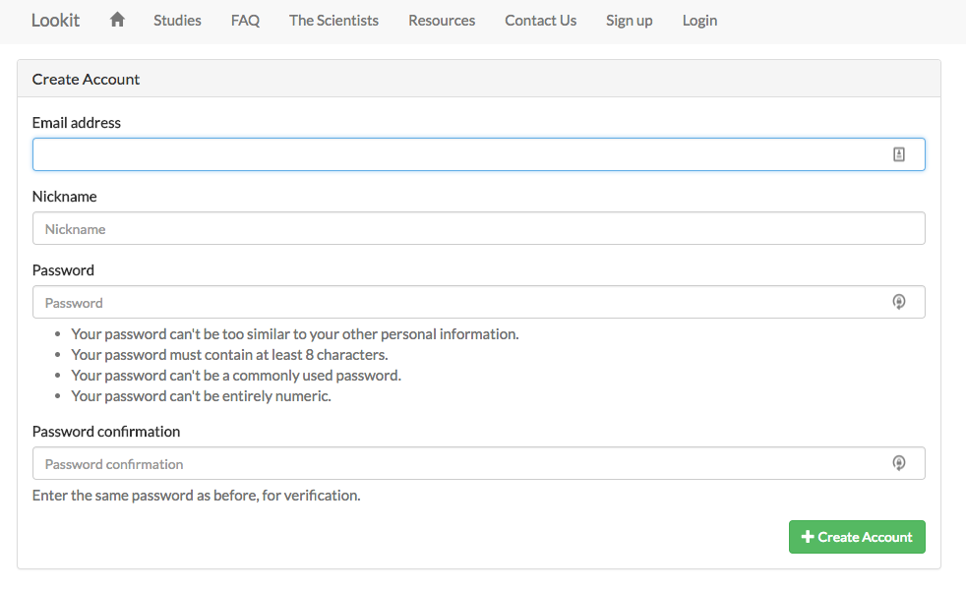

Child registration:
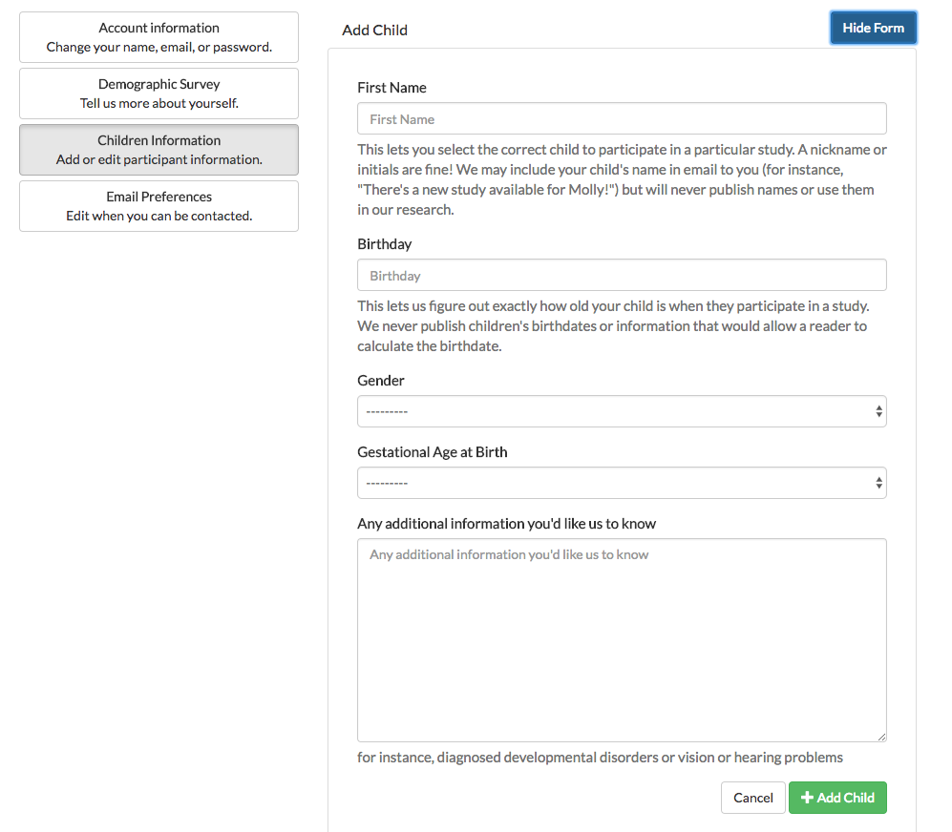
Email preferences:
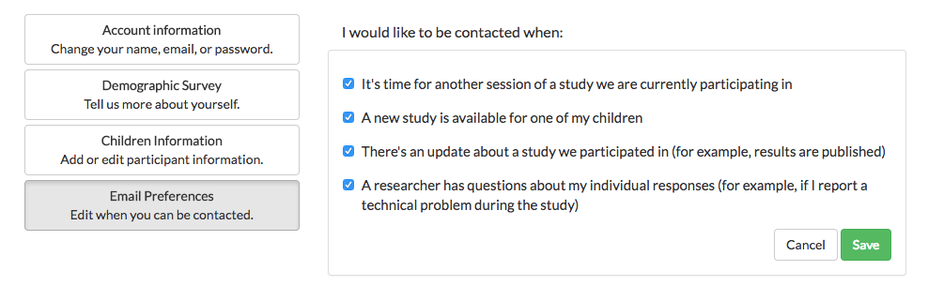
Demographic survey:
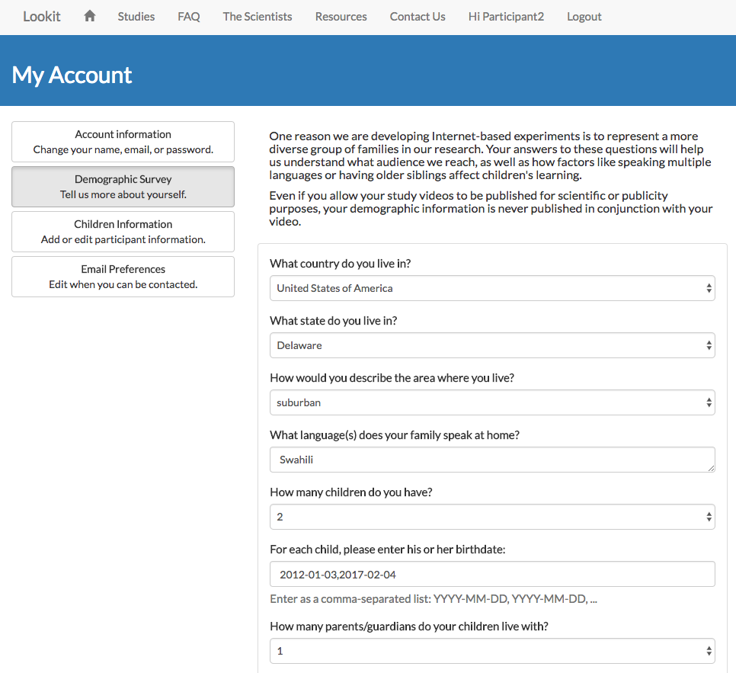

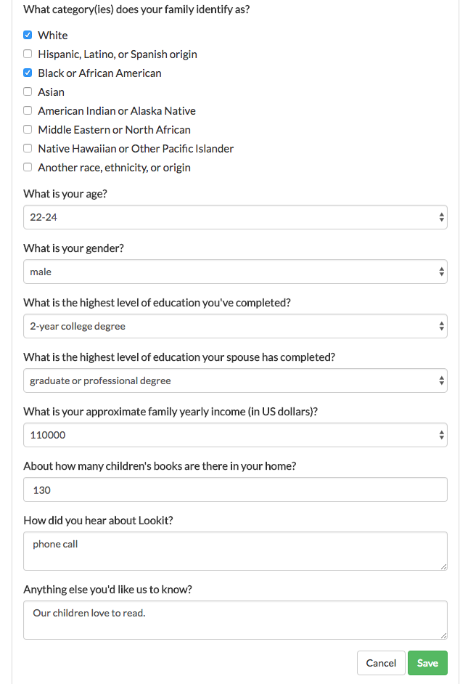
Standard exit survey:
